Question 4:

*PAC Chart:*

|  |  |  |  |
| --- | --- | --- | --- |
|  | *Given Data*   * *Card 1* * *Card 2* * *Card 3* * *Card 4* * *Card 5* |  | Required Results Output full house or not |
|  | Processing Needed   * Compare all the cards * Use if else statements (use AND and OR operators) * Compare all cards and verify if the conditions are met for a full house * Ensure the group of 3 and the group of 2 are different |  | Alternative Solutions  An array to store the cards and then count frequencies of each value. |

IPO Chart:

|  |  |  |  |  |
| --- | --- | --- | --- | --- |
| *Input*  • Integers:  c1, c2, c3, c4, c5 | *Processes*     1. Read 5 card values. 2. Compare 3. values to check i If: 4. Three cards are the same, and 5. The other two cards are the same, 6. And the groups are not identical. | | *Module*  *Reference*     1. Read 2. Calculate 3. Calculate 4. Print 5. Control | *Output*       * Output full house * Output not   a full  house |
|  |  | Decide whether the hand is a Full House or Not a Full House. |  |  |
|  | 4. | Output result |  |  |
|  | 5. | End |  |  |

IC Chart:

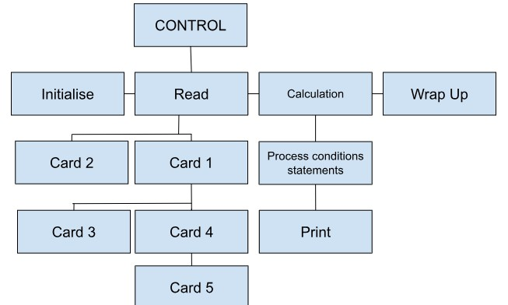

*Flowchart:*

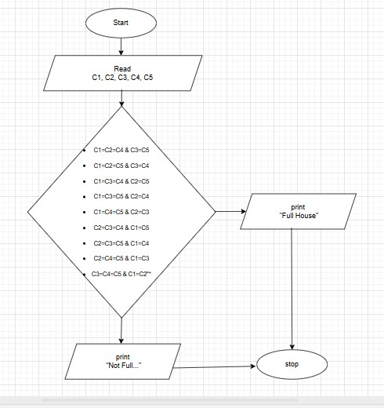

*Algorithm:*

* START
* Declare and input the five cards
* Read all cards
* Compare all the cards for all combinations for a full house
* If any of the above conditions is true
* Display "Full House"
* Else
* Display "NOT a Full House"
* STOP

*Pseudocode:*

Start   
Declare c1, c2, c3, c4, c5 as integers

Display "Input all your cards" Read c1, c2, c3, c4, c5

IF (

(c1 = c2 AND c2 = c3 AND c4 = c5 AND c1 <> c4) OR

(c1 = c2 AND c2 = c4 AND c3 = c5 AND c1 <> c3) OR

(c1 = c2 AND c2 = c5 AND c3 = c4 AND c1 <> c3) OR

(c1 = c3 AND c3 = c4 AND c2 = c5 AND c1 <> c2) OR

(c1 = c3 AND c3 = c5 AND c2 = c4 AND c1 <> c2) OR

(c1 = c4 AND c4 = c5 AND c2 = c3 AND c1 <> c2) OR

(c2 = c3 AND c3 = c4 AND c1 = c5 AND c2 <> c1) OR

(c2 = c3 AND c3 = c5 AND c1 = c4 AND c2 <> c1) OR

(c2 = c4 AND c4 = c5 AND c1 = c3 AND c2 <> c1) OR

(c3 = c4 AND c4 = c5 AND c1 = c2 AND c3 <> c1)

)

THEN

Display "Full House"

ELSE

Display "NOT a Full House"

END

Stop   
  
C code:

**C code:**# include<stdio.h>

int main(){

     int c1, c2, c3, c4, c5;

      printf("input all your cards m8 \n");

       scanf("%d %d %d %d %d", &c1, &c2, &c3, &c4, &c5);

// Gonna put all possible combinations for a full hand in a if statement

if( //1,2,3 & 4,5

       (c1 == c2 && c2 == c3 && c4 == c5 && c1 != c4) ||

       //1,2,4 & 3,5

  (c1 == c2 && c2 == c4 && c3 == c5 && c1 != c3) ||   //1,2,5 & 3,4

  (c1 == c2 && c2 == c5 && c3 == c4 && c1 != c3) ||   //1,3,4, & 2,5

  (c1 == c3 && c3 == c4 && c2 == c5 && c1 != c2) ||   //1,3,5 & 2,4

  (c1 == c3 && c3 == c5 && c2 == c4 && c1 != c2) ||   //1,4,5  & 2,3

  (c1 == c4 && c4 == c5 && c2 == c3 && c1 != c2) ||   //2,3,4 & 1,5

  (c2 == c3 && c3 == c4 && c1 == c5 && c2 != c1) ||   //2,3,5 & 1,4

  (c2 == c3 && c3 == c5 && c1 == c4 && c2 != c1) ||   //2,4,5 & 1,3

  (c2 == c4 && c4 == c5 && c1 == c3 && c2 != c1) ||

  // 3,4,5 & 1,2

  (c3 == c4 && c4 == c5 && c1 == c2 && c3 != c1)  )

{

        printf("Full House\n");

    } else {

        printf("NOT a Full House\n");

    }

return 0;

}